# Performance Metrics

# Classification Report

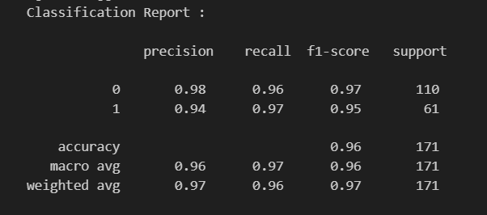

# Accuracy

